Day: 15 (02-11-2026) | AWS VPC Setup & Management | Documented By:
Task – 3 | AWS VPC Setup & Management | Sujit T K

- Create VPC with name aji-vpc CIDR: 10.1.0.0/16
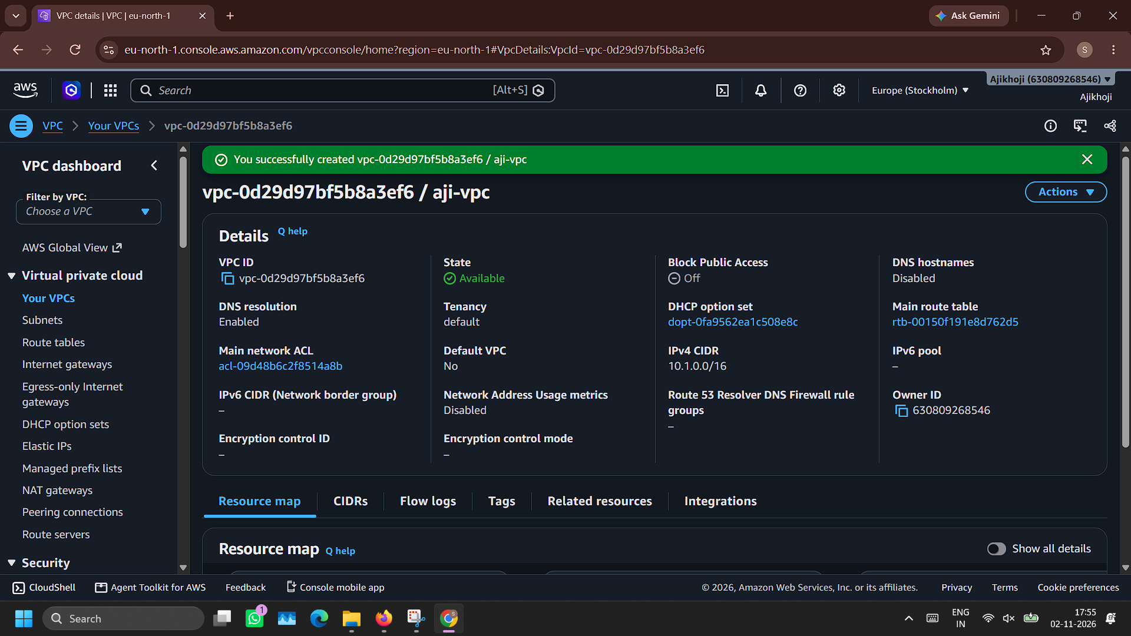
- Create public subnet with name aji-public-subnet
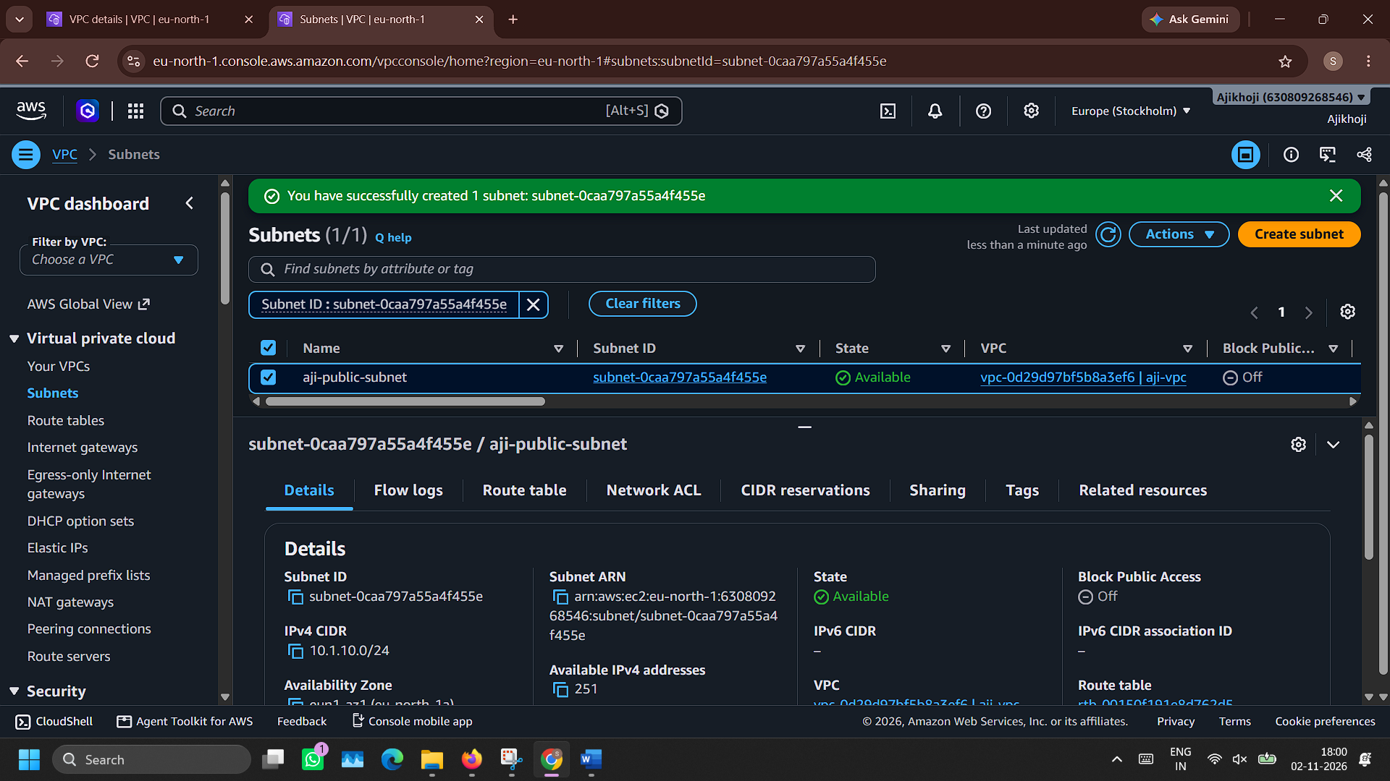

- Create private subnet with name aji-private-subnet
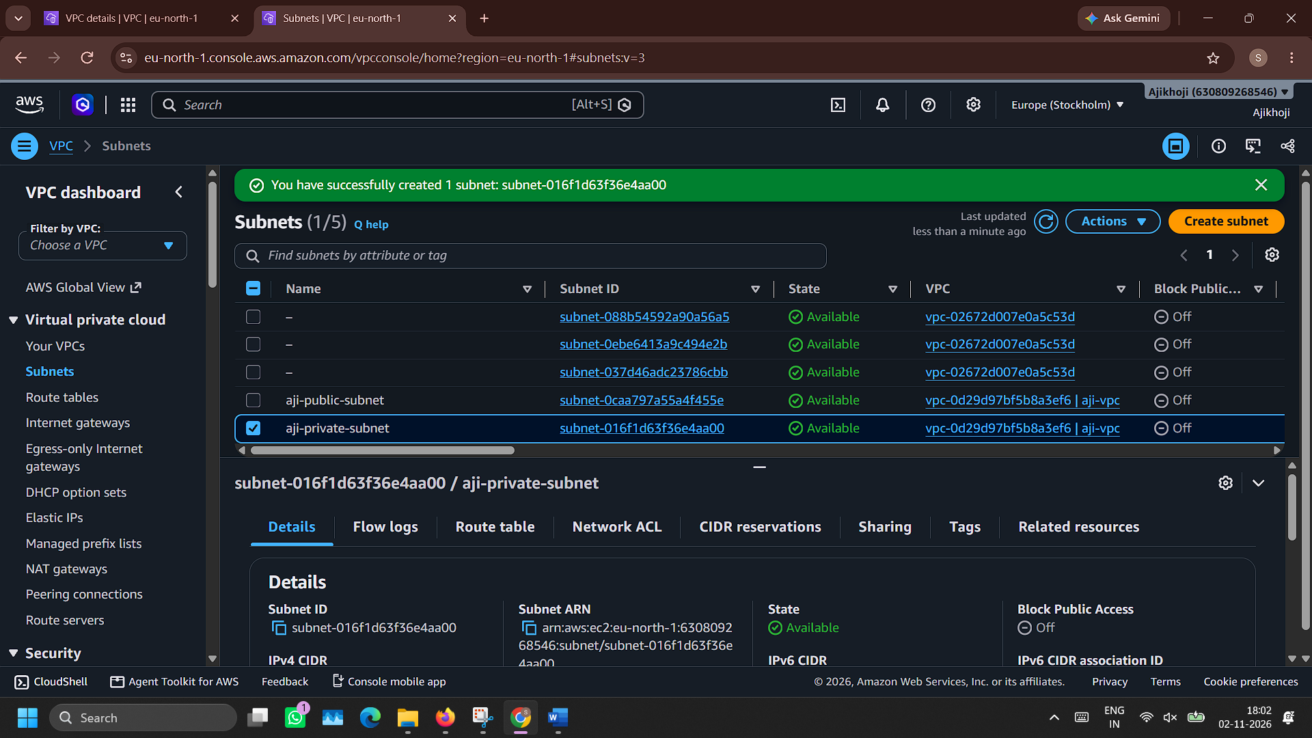
- Create an Internet Gateway named aji-internet-gateway
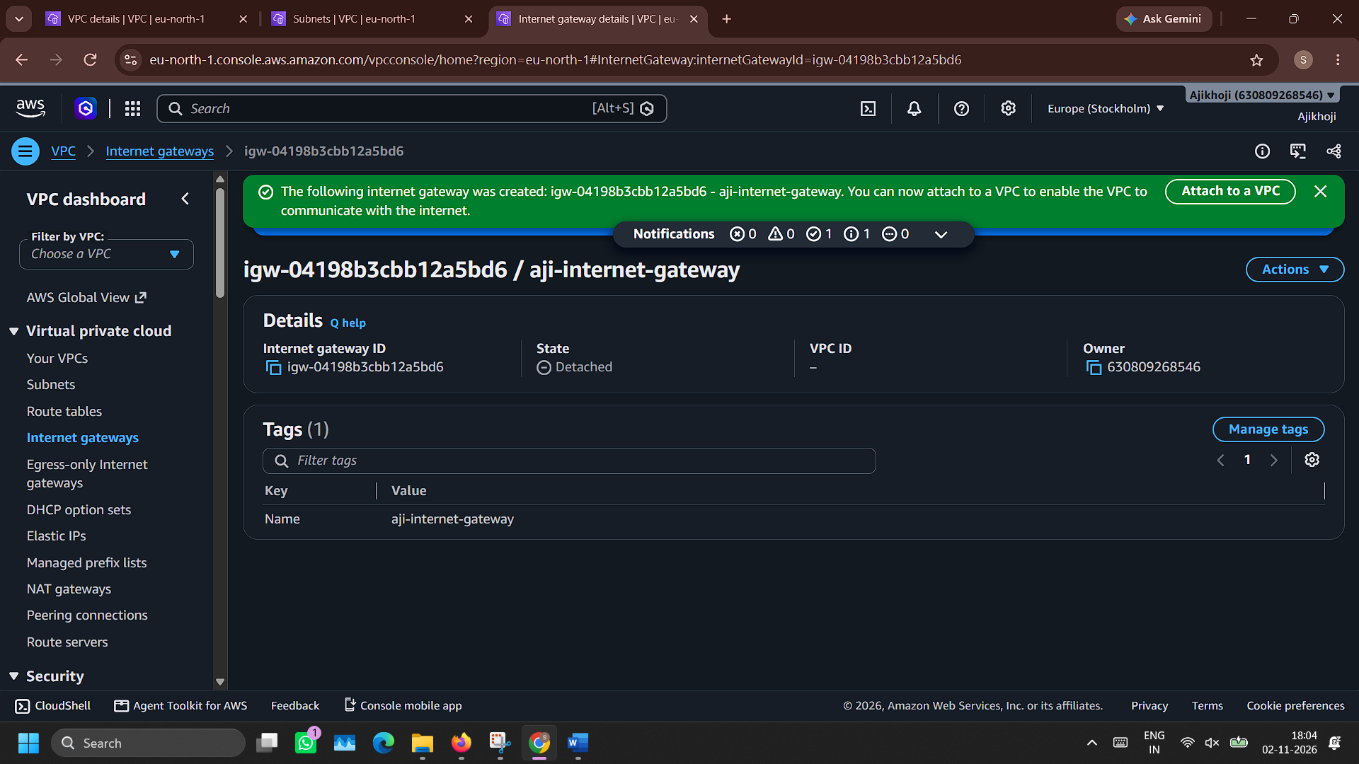

- Attach to VPC aji-vpc
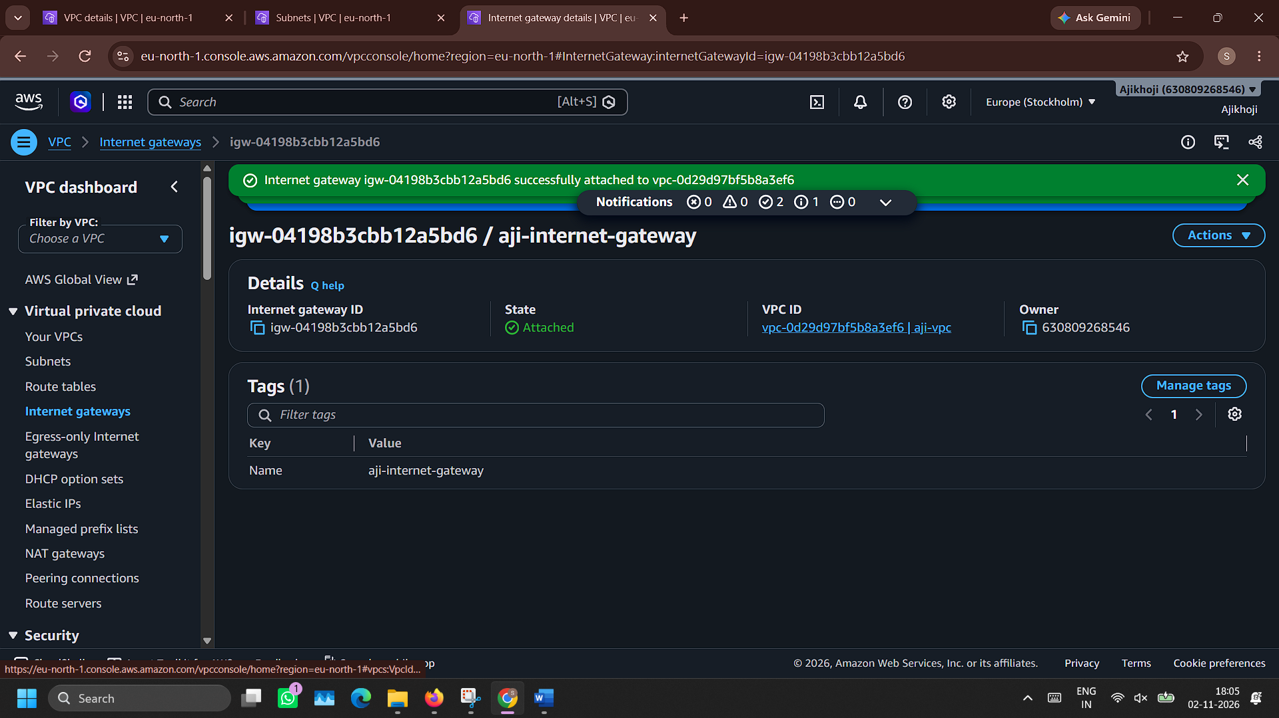
- Create a route table for public subnet with name aji-public-route-table
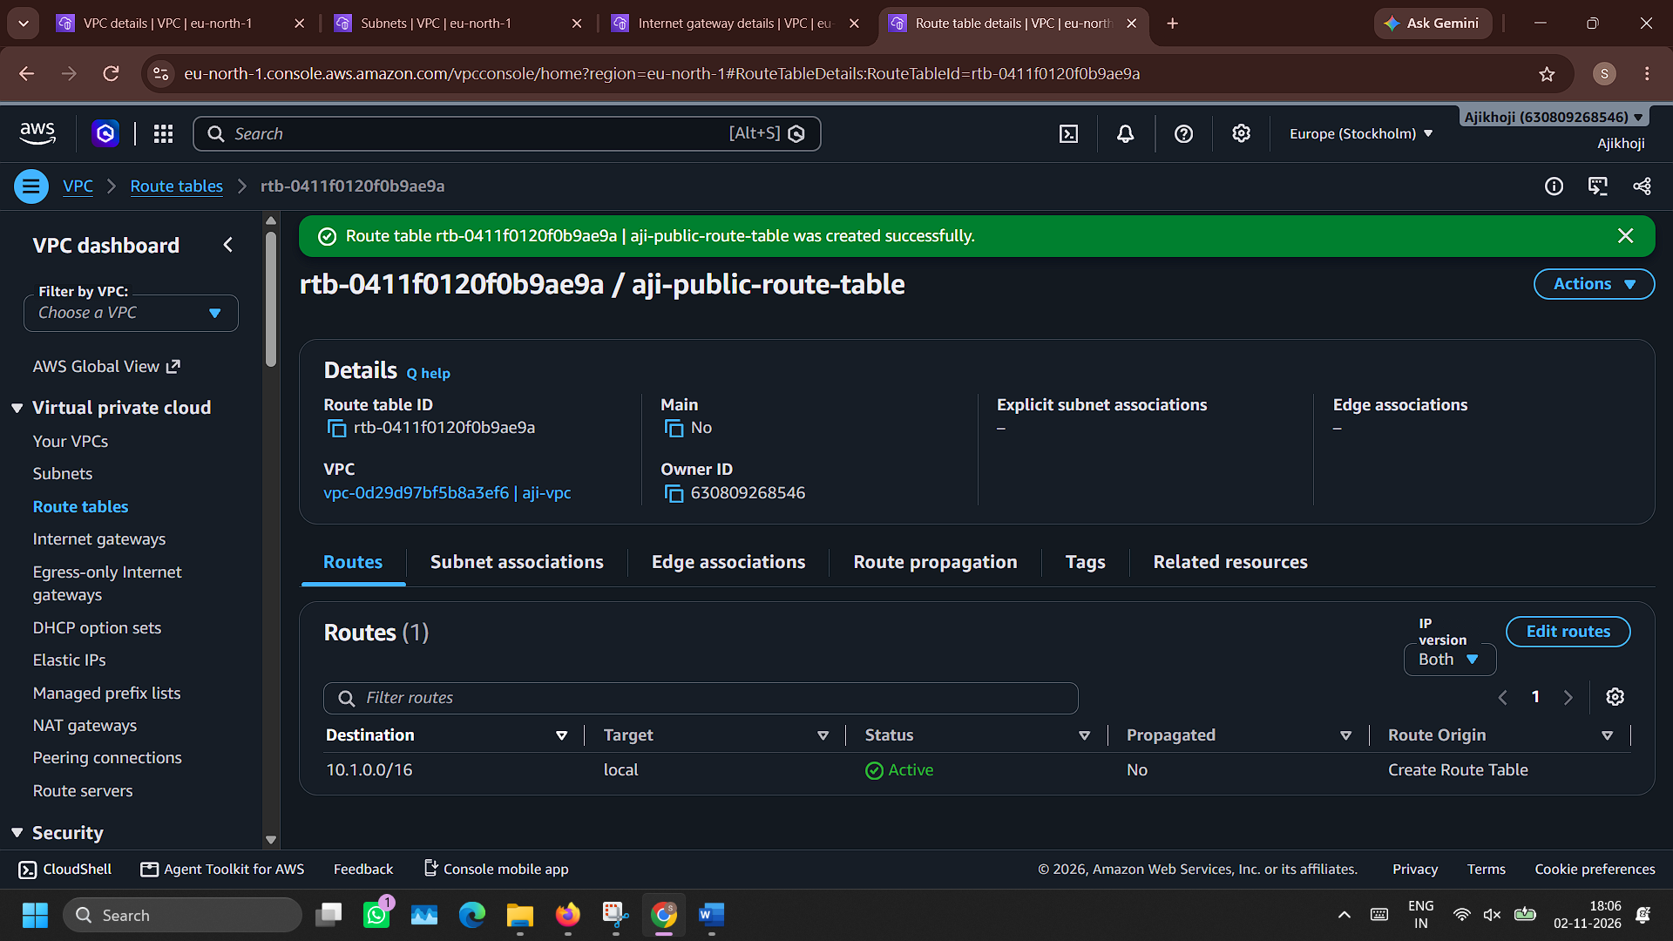

- Attach Internet gateway aji-internet-gateway to route aji-public-route-table
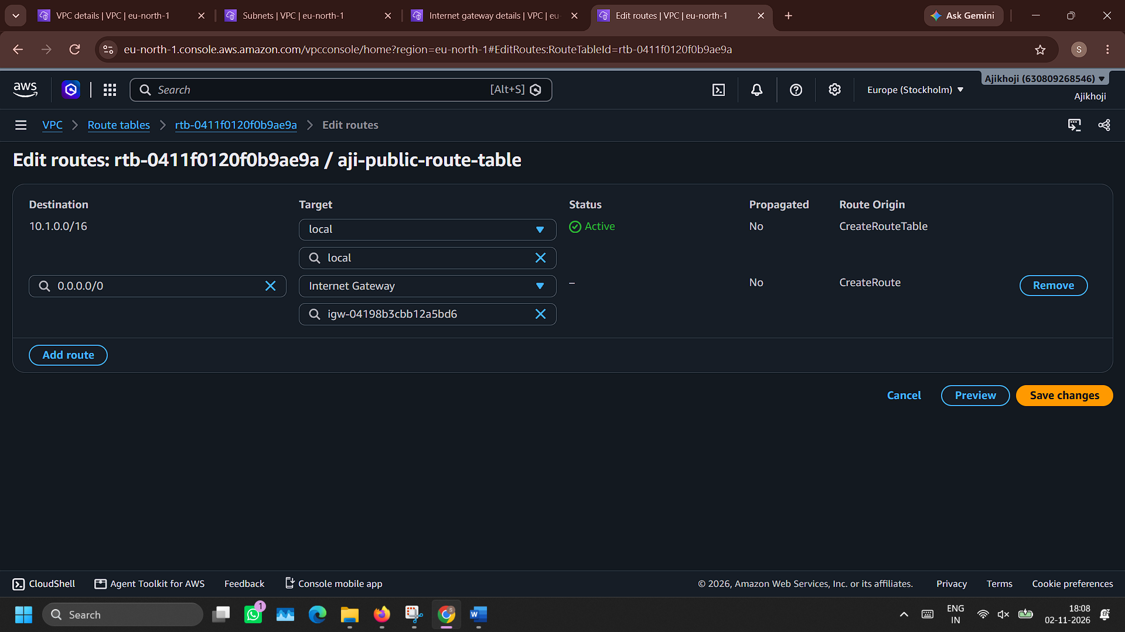

- Create a route table for private subnet with name aji-private-route-table
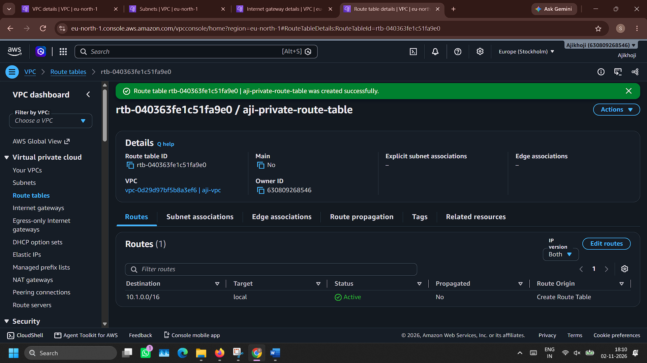

- Associate route table aji-public-route-table with subnet aji-public-subnet
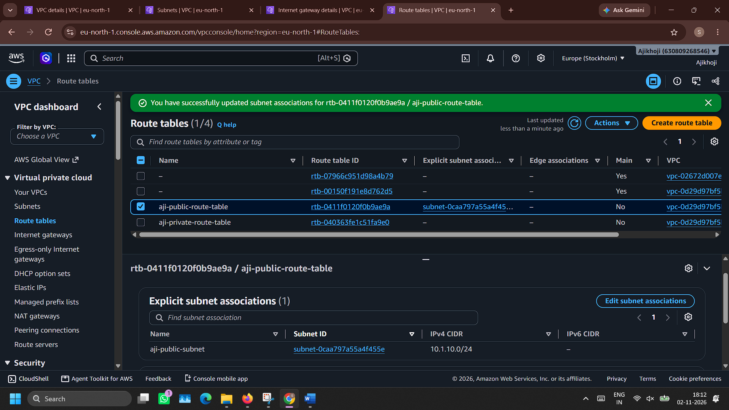

- Create NAT gateway with name aji-nat-gateway and choose aji-public-subnet as subnet
Wait for the state to become ‘Available’
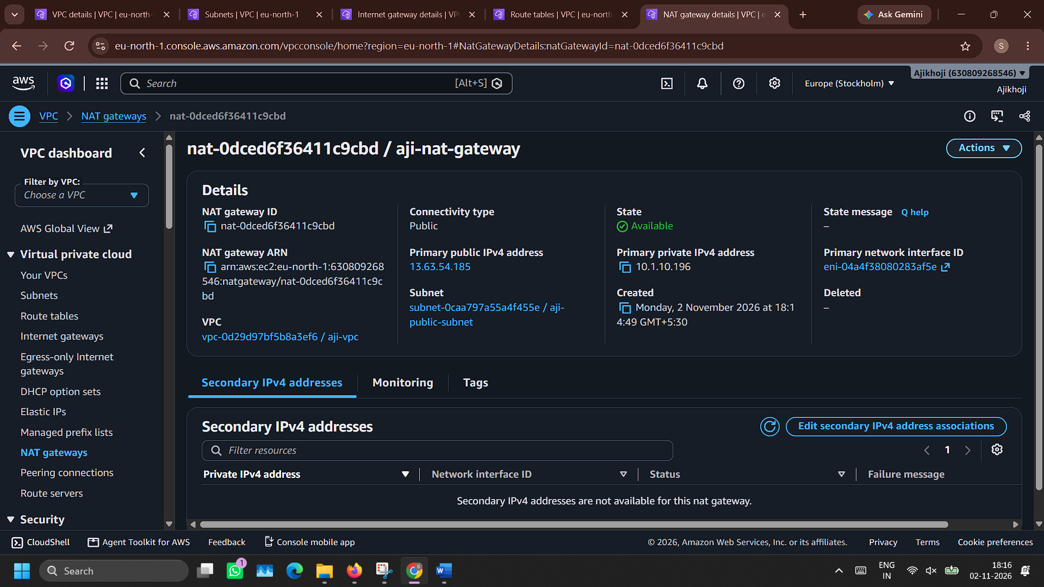

- Configure NAT Gateway aji-nat-gateway in Route tab of route table aji-private-route-table
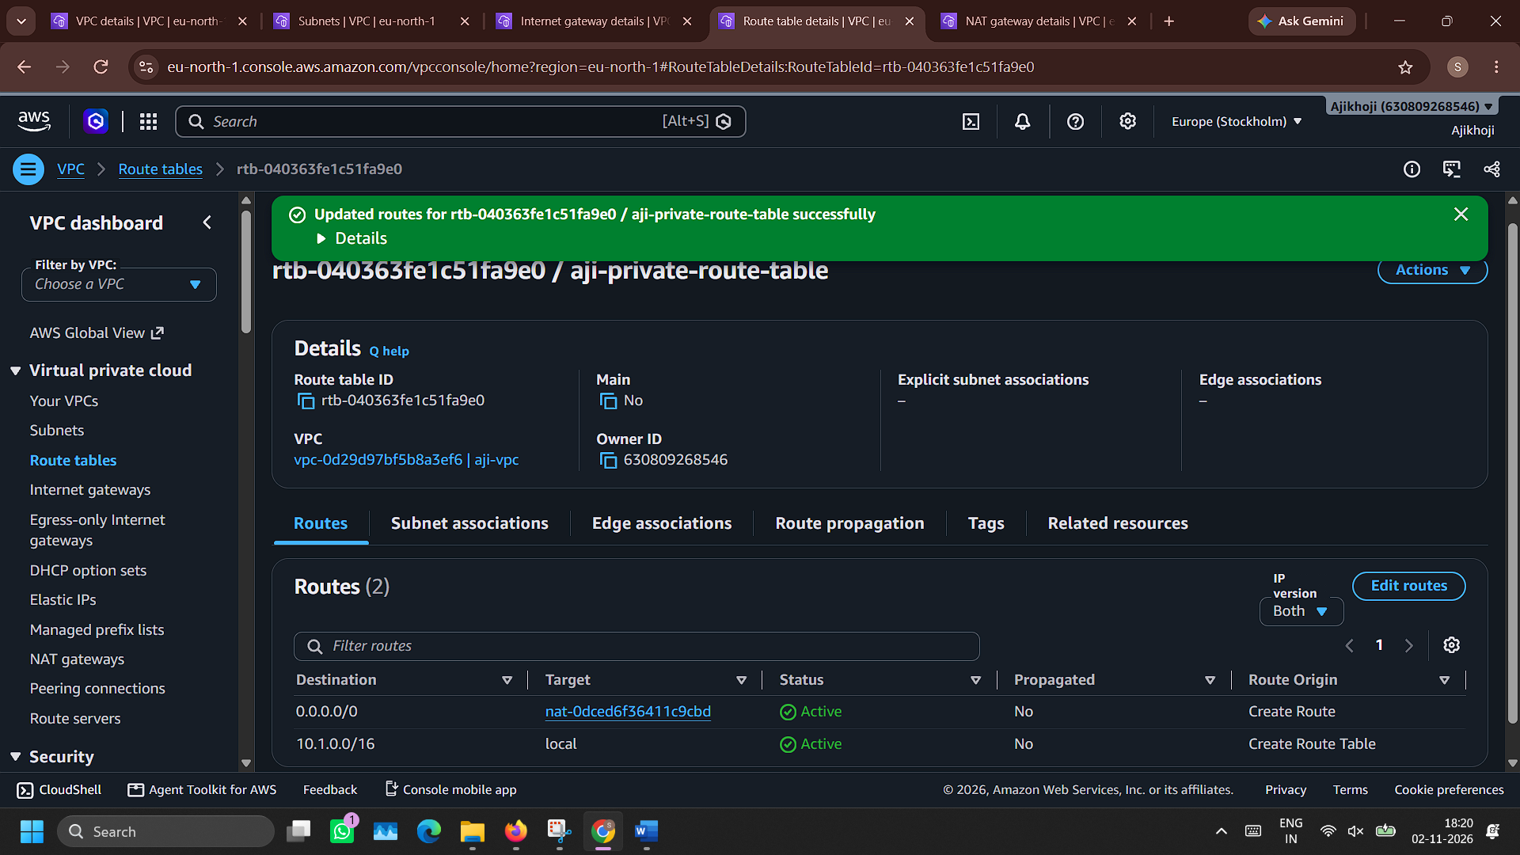

- Associate route table aji-private-route-table with subnet aji-private-subnet
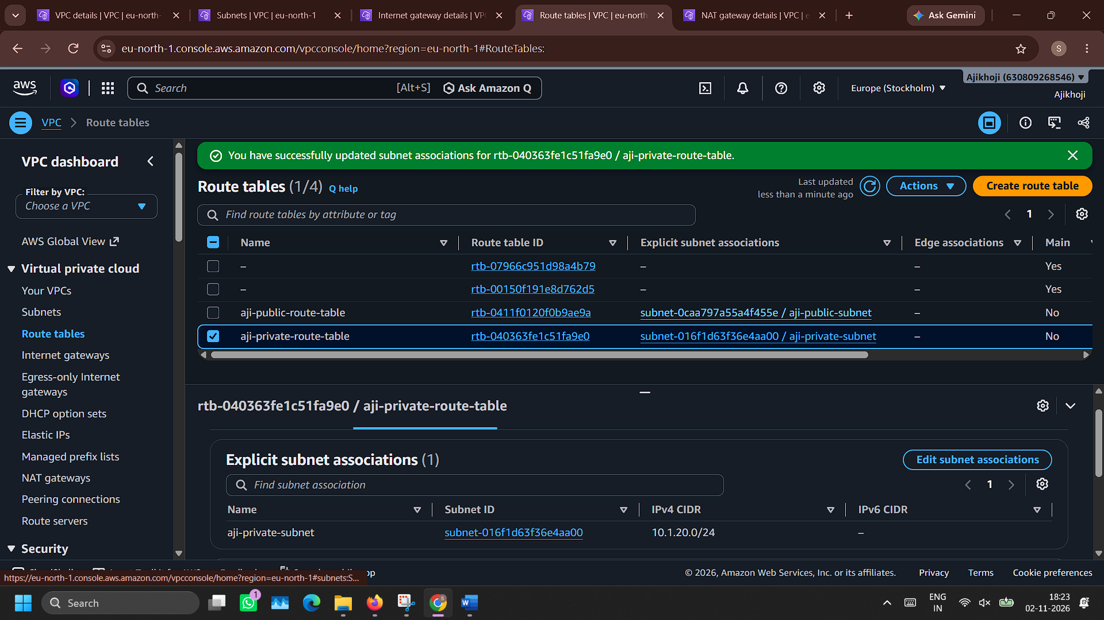

- Create security group aji-public-security-group with SSH (My-IP), HTTP (Anywhere IPv4) and HTTPS (Anywhere IPv4) configuration in inbound rule
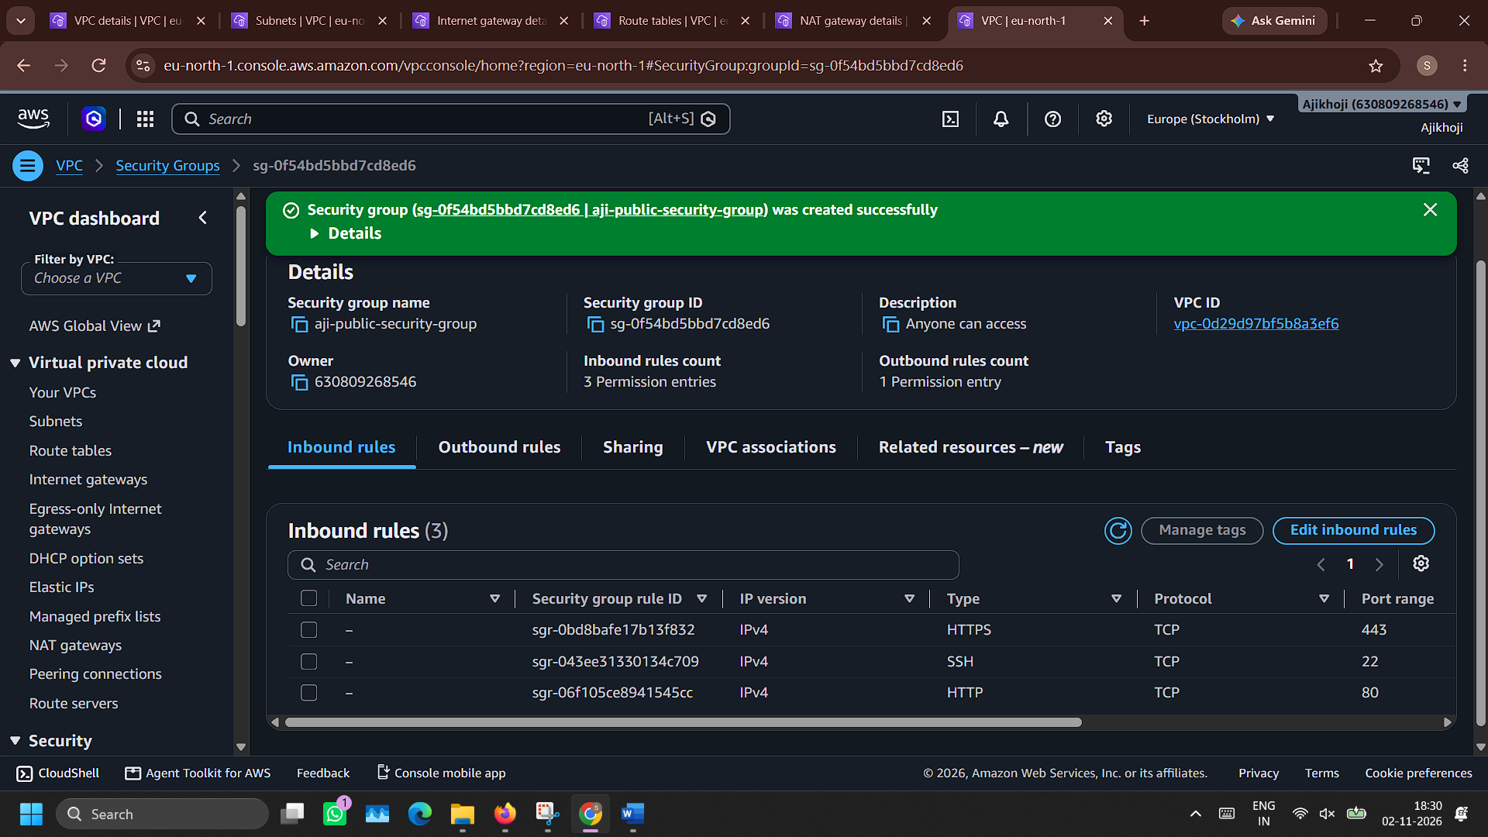

- Create security group aji-private-security-group with SSH (My-IP), HTTP (Anywhere IPv4) and HTTPS (Anywhere IPv4) configuration in inbound rule
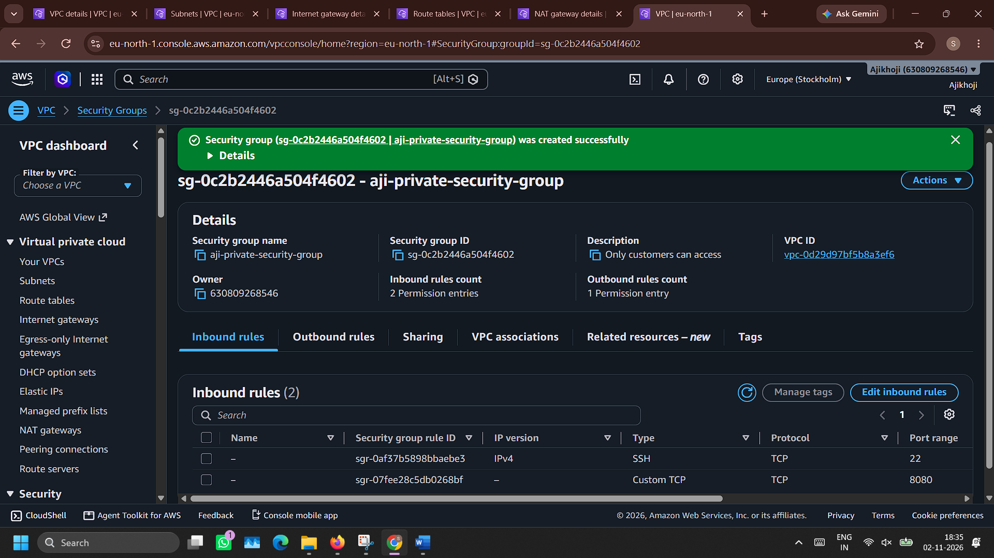

- Public EC2 created
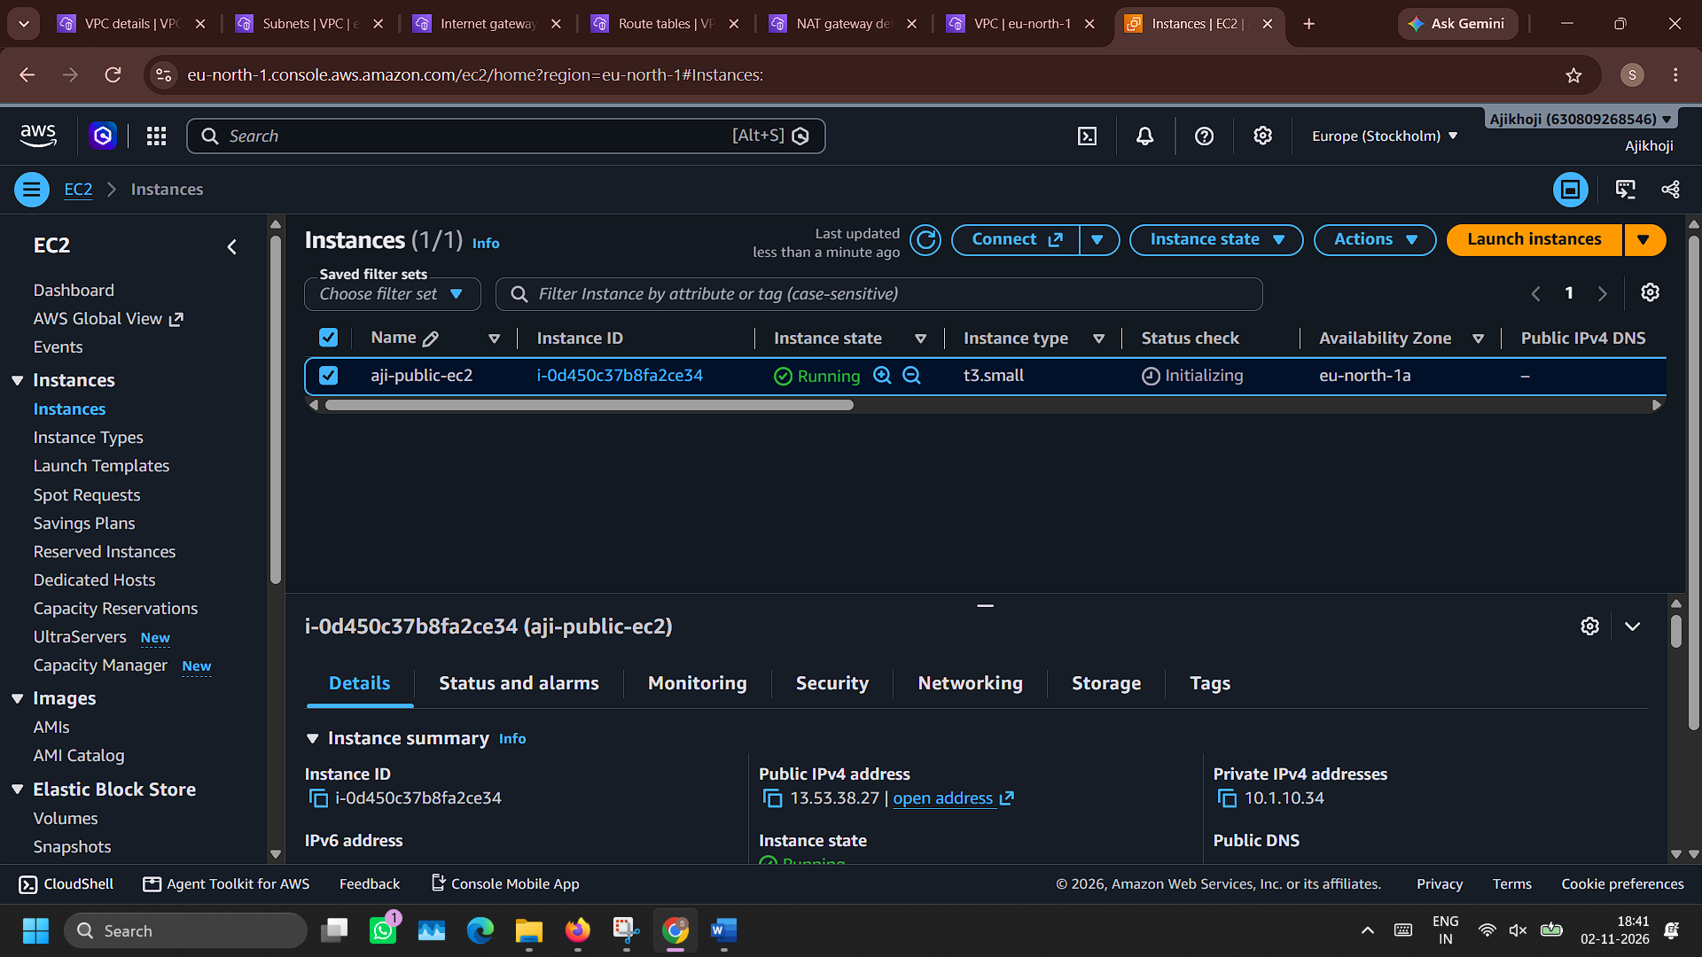

- Private EC2 created


